# Where To Download VM

## Linux Images

From my own experience, images provided by **this site is stable**. It provides both minimal version (only command line) and graphic version for each image. Make sure to **follow the guideline** for opening the VM images on the site.

<https://www.linuxvmimages.com/>

## Windows Images

# VMWare Workstation vs. VirtualBox

For a complete VMWare Workstation vs. VirtualBox comparison and **many helpful feature explanations** about virtual machines, check <https://www.nakivo.com/blog/vmware-vs-virtual-box-comprehensive-comparison/>.

**From my own experience, VMWare Workstation is way better than VirtualBox**.

I struggled with following kinds of issues when working on VirtualBox:

* Cannot copy/paste clipboard between host and VM (though enable copy/paste setting and install Guest Additions).
* Cannot copy/paste files between host and VM (though enable drag and drop setting and install Guest Additions).
* Very inconvenient for the mouse to switch between host and VM. Have to press Right Ctrl every time.
* Sometimes get error "failed to fetch …" when downloading packages (cannot understand why but I got this issue on both Ubuntu and CentOS. After that, I switched to VMWare and the error was gone. So I guess the VirtualBox is the cause – maybe network connection or server is the root cause, but I still cannot fix it).
* Package gnome-shell-extensions failed to install. Cause auto logging out when using. Very very frustrating!

## VMWare Workstation

### Shared Folder

Everything here:

<https://docs.vmware.com/en/VMware-Workstation-Player-for-Windows/15.0/com.vmware.player.win.using.doc/GUID-0C23FCBF-F0CC-447B-A08E-35B90C52091E.html>

**Main steps**:

1. Install *VMWare Tools* (from VMWare Workstation > VMWare Tools Installation > follow the guide)
2. Mounting shared folder

At the end, don't forget to enable advanced features:

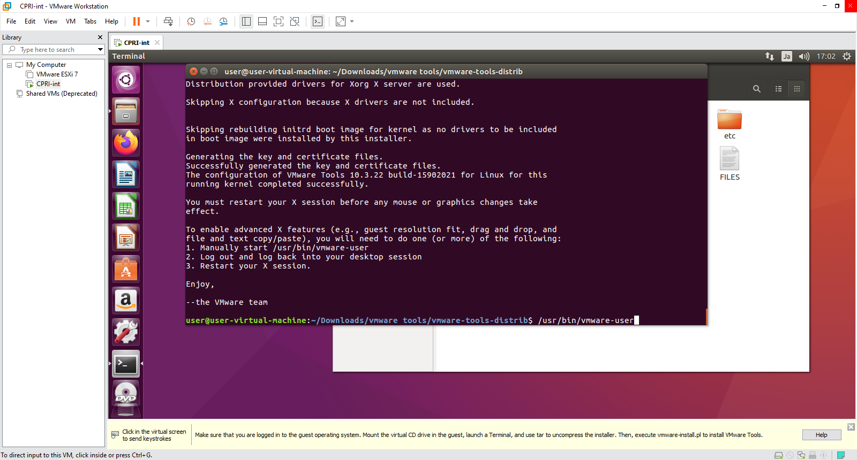

**Warnings:**

VMWare does not support symbolic links for Window host – Linux guest in shared-folder mode.

The attempt to create symbolic links in shared-folder mode will lead to this error: "*ln: failed to create symbolic link … Operation not supported.*" Details [here](https://discourse.pro/t/topic/256/2).

For Linus host – Windows guest, VMWare supports a [way](https://kb.vmware.com/s/article/1007277) to fix this error.

## VirtualBox

### Shared Folder

**Main steps:**

1. Install *VB Guest Additions*: <https://www.tecmint.com/install-virtualbox-guest-additions-in-centos-rhel-fedora/>
2. Mount shared folder: <https://serverfault.com/a/674976>

### Ubuntu on VirtualBox

Speed up Ubuntu on VirtualBox: <https://www.linuxbabe.com/virtualbox/speed-up-ubuntu-virtualbox> (Ubuntu running on VirtualBox is very slow, compared to other Linux distributions).

# Network

## Bridged vs. NAT vs. Host Only

<https://communities.vmware.com/t5/VMware-Workstation-Player/accessing-laptop-s-wifi-hardware/td-p/2548083>

## Adding Network Adapter

In most cases, network adapter (either wired or wireless) is added by default when we download the VM image. However, if it's not added (of course, we cannot access the Internet), we have to do that manually.

**How to know if a network adapter is not added?**

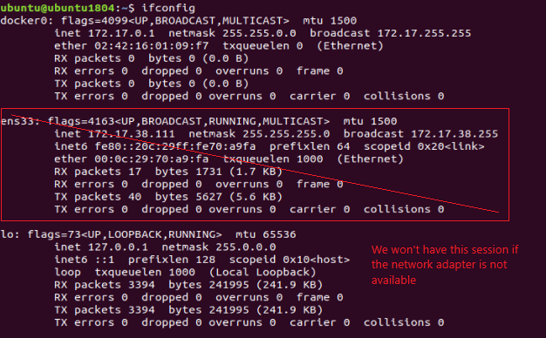

**Note**: The device is named 'ens33' in this example, but the naming rule is actually 'ens***'. So, it can be a different number.

**How to add a network adapter via Network Manager CLI?**

Try one of two following ways:

<https://unix.stackexchange.com/a/560951>

<https://unix.stackexchange.com/a/525842>

## Using Wi-Fi in VMs

You CANNOT find your wireless adapter within the virtual machine. It doesn't see your real hardware but only "virtual hardware" provided by the virtualization product. Detailed explanation [here](https://askubuntu.com/a/1212985).

So, if you want to have Wi-Fi in your VMWare guest, you must follow one of these approaches:

1. Provide your own Wi-Fi network adapter in the form of a **USB Wi-Fi network adapter**.
2. Some say "Use an automatic **Bridged** connection. This will directly connect to your computers physical network".

Some say "Wireless connections cannot be bridged". Detailed explanation [here](https://superuser.com/a/1114171).

NOTE: I tried Bridge, and it WORKS.

1. Configure NAT network settings, such as [this video](https://www.youtube.com/watch?v=bdPa4kBN72I&ab_channel=AnoopRana).

# SSH Between Host and VM Guest

## Between Local Host and Local VM Guest

Running virtual machines with an UI can significantly slow down the whole computer. A simple yet effective trick to improve the performance is commanding the VM via SSH, while letting the VM runs on background.

1. Get IP address of the Linux guest with ifconfig command.

2. Verify the guest's IP address to make sure it can be accessed from the host:

ping <guest-ip>

3. Connect to the guest via SSH:

ssh [guest-user@]guest-ip[:port]]

This confirmation only shows up for the first time accessing guest from Windows host.

Example:

C:\Users\triho>ssh centos@192.168.86.129

The authenticity of host '192.168.86.129 (192.168.86.129)' can't be established.

ECDSA key fingerprint is SHA256:f63GDTlNka9UzwsdXcS5xoN24E3/27lzvZ2Qj/ioFR4.

Are you sure you want to continue connecting (yes/no)? yes

Warning: Permanently added '192.168.86.129' (ECDSA) to the list of known hosts.

+-+-+-+-+-+-+-+-+-+-+-+-+-++-+-+-+-+-+-+-+-+-+-+-+-+-+-+-+-+-++-+-+-+

L I N U X V M I M A G E S . C O M

+-+-+-+-+-+-+-+-+-+-+-+-+-+-+-+-+-+-+-+-+-+-+-+-+-+-+-+-+-+-+-+-+-+-+

User Name: centos

Password: centos (sudo su -)

centos@192.168.86.129's password:

Last login: Sun Sep 13 11:36:33 2020 from 192.168.86.1

+-+-+-+-+-+-+-+-+-+-+-+-+-++-+-+-+-+-+-+-+-+-+-+-+-+-+-+-+-+-++-+-+-+

L I N U X V M I M A G E S . C O M

+-+-+-+-+-+-+-+-+-+-+-+-+-+-+-+-+-+-+-+-+-+-+-+-+-+-+-+-+-+-+-+-+-+-+

User Name: centos

Password: centos (sudo su -)

[centos@centos7 ~]$

[centos@centos7 ~]$ ls

Desktop Documents Downloads Music Pictures Public Templates Videos

[centos@centos7 ~]$ exit

logout

Connection to 192.168.86.129 closed.

## Between Local Host and Remote VM Guest

See section 'SSH between Windows Host and Linux Guest which run on VMWare Player / Virtual Box on another computer' of *Personal\Tutorials\Network\ Communication Protocols.docx*.